**ASSIGNMENT – 26.4**

**Problem Statement:**

Implement view in hive by following the steps in the below blog:

<https://acadgild.com/blog/hive-view-introduction/>

**Output:**

**Hive View:**

For writing queries, we sometimes find it difficult to frame query when it is nested and complex.

This scenario may often occur in the case of joins and we will be covering the same in this blog to simplify our way of querying in HIVE with help of VIEWS.

When a query becomes long or complicated, a view may be used to hide the complexity by dividing the query into smaller, more manageable pieces; similar to writing a function in a programming language or the concept of layered design in software.

Encapsulating the complexity makes it easier for end users to construct complex queries from reusable parts.

**We have following tables:**

* Emp_salary
* employee

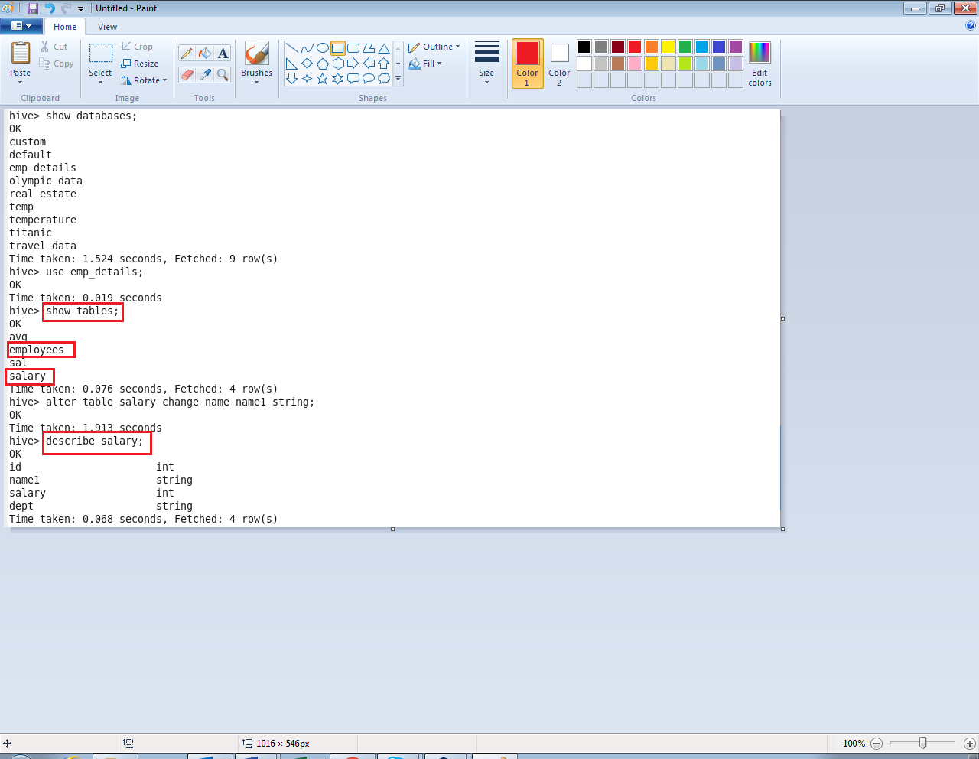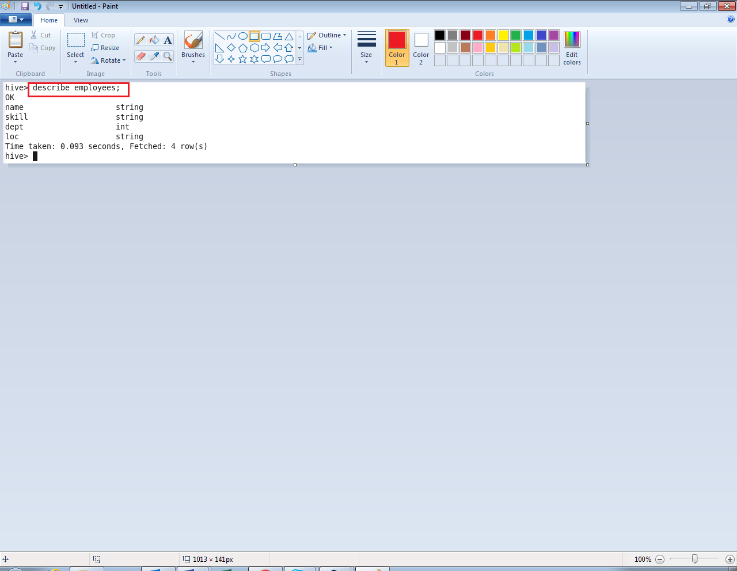

We are creating a view on join of these two tables.

The view name is view_emp.

We joined the tables on the basis of column which holds the employee name.

